# Movies Data Analysis and Business Insights

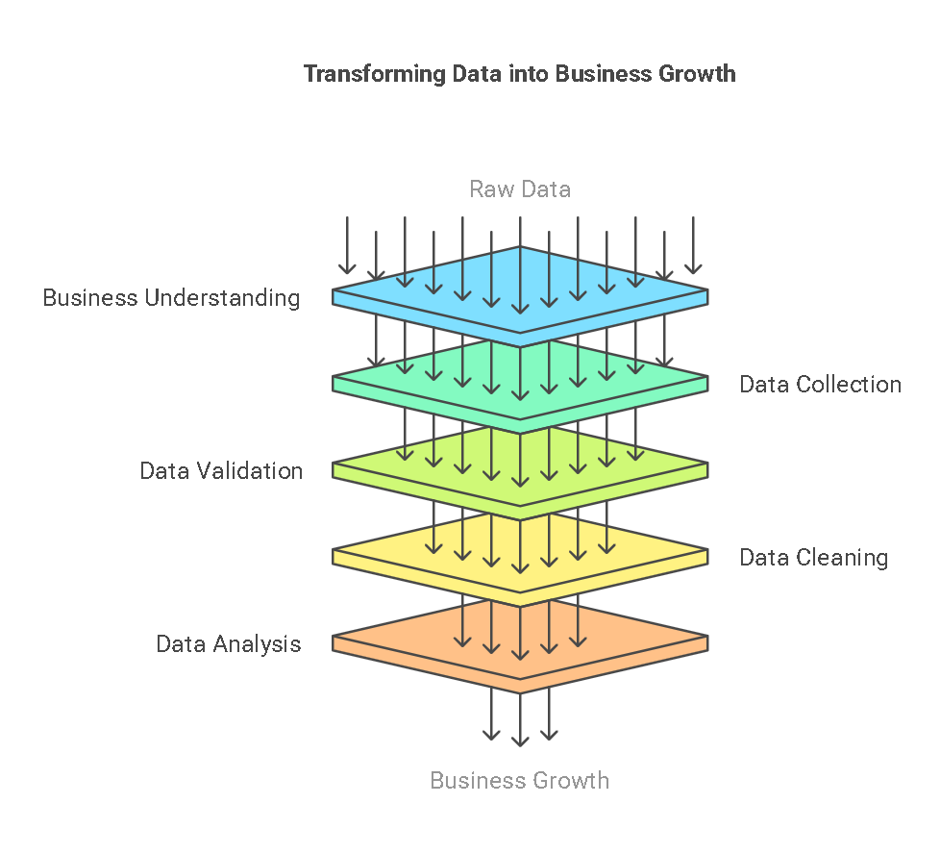

## Business Understanding

The primary objective of this analysis is to evaluate the financial performance of movies and identify key factors that contribute to their success. By examining budget allocations, box office collections, return on investment (ROI), and other influencing parameters such as genre, critic ratings, and multiplex availability, stakeholders can make data-driven decisions. This analysis helps producers, investors, and distributors in optimizing production strategies and maximizing profitability.

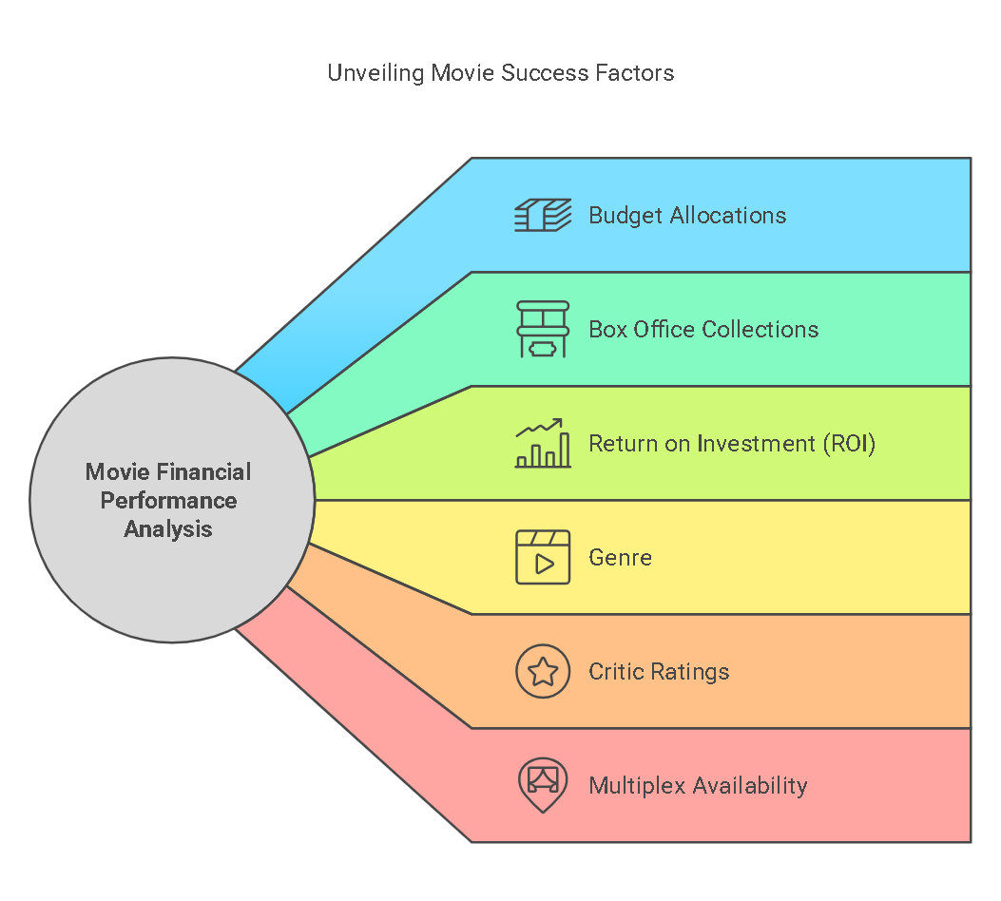

## Data Required

To conduct this study effectively, several key data points are required. These include budget, box office collections, movie genres, ROI, 3D availability, total ratings from viewers, multiplex coverage, critic ratings, Oscar wins, and the average age of actors in the movie. This data is essential to assess profitability, audience preferences, and the impact of various factors on a movie’s success.

## Data Collection

The data is sourced from multiple industry reports, movie databases (such as IMDb and Rotten Tomatoes), and financial statements from production companies. Box office reports provide figures on collections, while professional critics’ platforms contribute to understanding the impact of ratings. Multiplex distribution data is collected from theater chains, and information on awards and technical achievements is retrieved from award records.

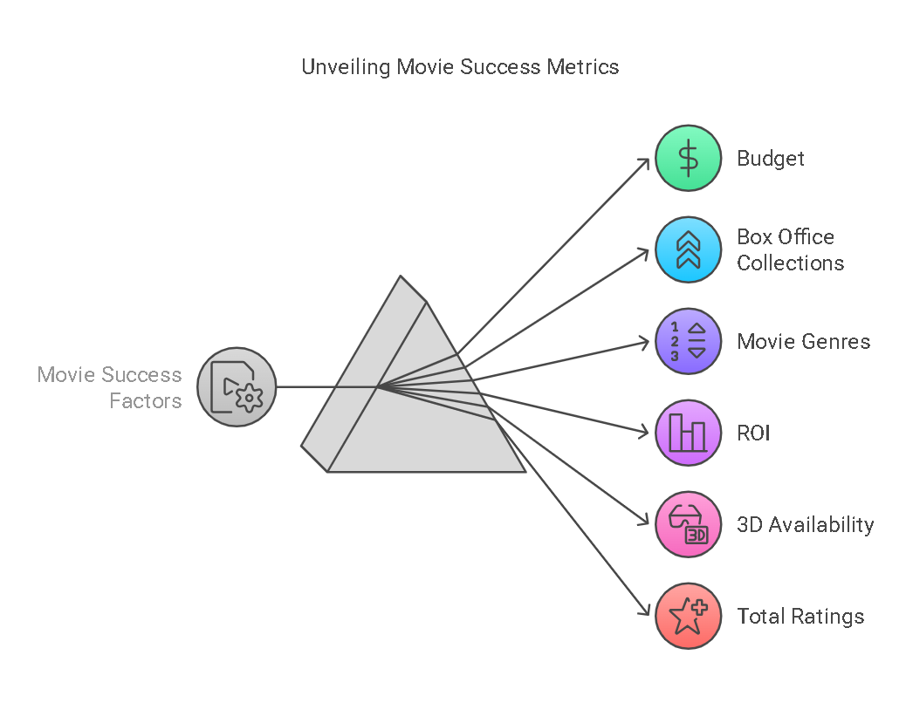

## Data Validation & Understanding

Once collected, the data undergoes thorough validation to ensure accuracy and consistency. Budget versus collection analysis is conducted to determine profitability. ROI is analyzed across different genres to identify high-performing categories. The influence of 3D technology on financial returns is examined, along with multiplex coverage to understand the role of wider distribution in revenue generation. Critic ratings and award recognitions are also evaluated to measure their correlation with box office success.

## Data Cleaning

Data cleaning is a crucial step to eliminate inconsistencies and enhance data accuracy. This involves handling missing values in budget, collection, and rating fields, standardizing categorical variables such as genre names, removing duplicate entries, and filtering extreme outliers that could skew the analysis. Ensuring clean data improves the reliability of insights derived from the analysis.

## Analysis Using Tools

Various analytical tools are employed to process and interpret the data. Power BI and Tableau are used to visualize trends and correlations, In this analysis I have used Tableau Desktop and Napkin Ai, while Excel helps in data aggregation and preliminary calculations. Advanced analysis is performed using Python (Pandas, Matplotlib, and Seaborn) to derive deeper statistical insights into movie performance and influencing factors.

## Dashboard Insights

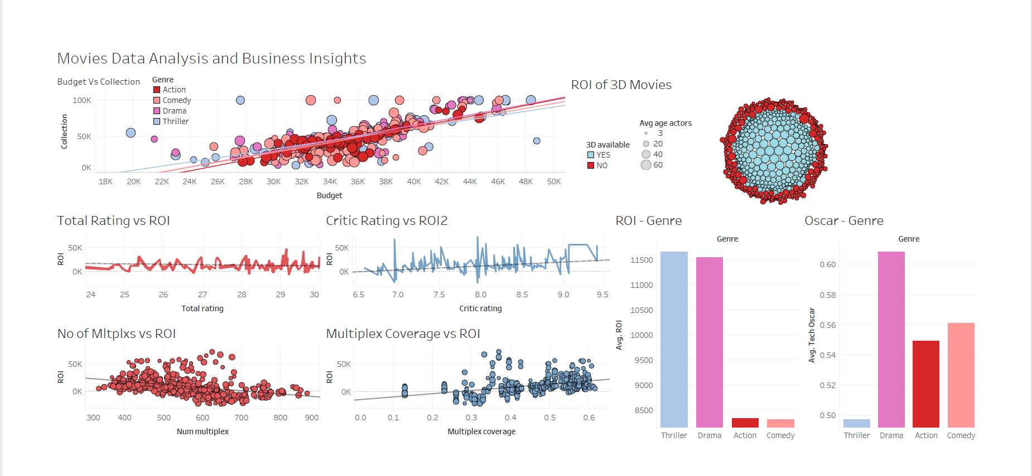

### ****Meaningful Insights from the Movies Dashboard Analysis****

The provided movies dashboard presents key data on budget, collections, return on investment (ROI), genre-based performance, multiplex coverage, critic ratings, and other factors influencing a movie's success. Below are the key insights drawn from the analysis:

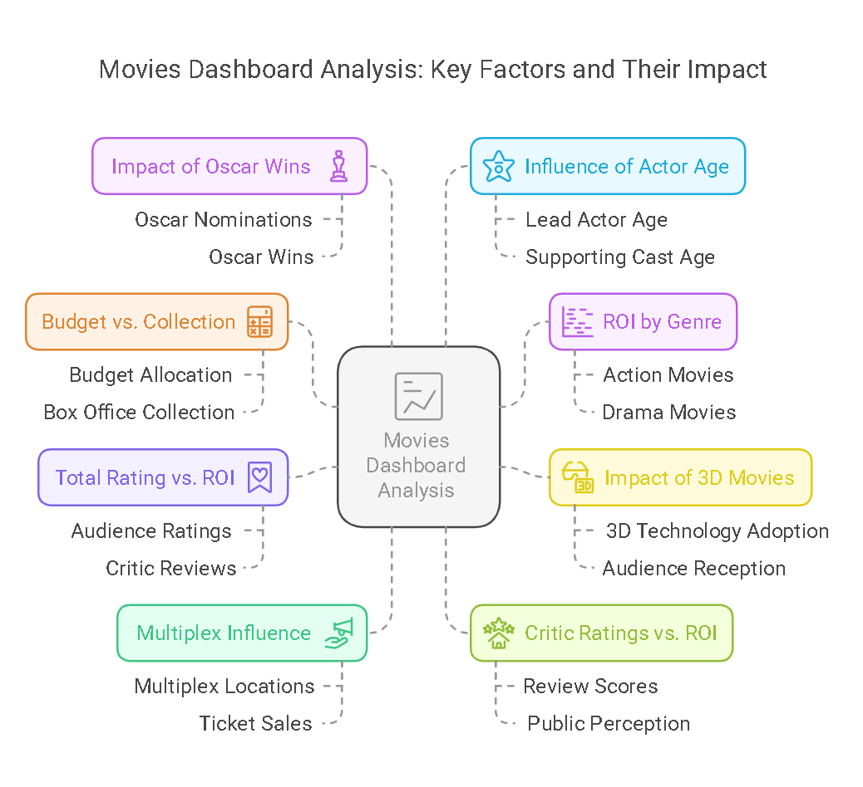

### ****1. Budget vs. Collection Analysis****

* There is a clear correlation between the budget and box office collection, but higher budgets do not always guarantee higher earnings.
* Some lower-budget movies have achieved significant success, indicating that content and audience engagement play a crucial role in profitability.
* The ideal strategy is to optimize budget allocation rather than over-investing in production costs.

### ****2. ROI by Genre****

* **Thriller and Drama** genres have the highest ROI, meaning these genres are the most profitable.
* **Action and Comedy** genres show moderate ROI, indicating that while they generate good revenue, their higher production costs reduce profitability.
* Investors should focus more on Thriller and Drama movies for higher returns, especially if production costs can be controlled.

### ****3. Impact of 3D Movies on ROI****

* Movies available in **3D format** tend to have slightly better ROI compared to non-3D movies.
* The difference in ROI is not massive, suggesting that 3D technology adds value but is not a sole determinant of success.
* Filmmakers should assess the audience demand before investing heavily in 3D technology.

### ****4. Total Rating vs. ROI****

* Higher **total ratings** are linked with better ROI, indicating that audience feedback and engagement strongly influence profitability.
* Movies with ratings between **8.0 – 9.5** have consistently higher ROI.
* Improving storytelling, character development, and direction can boost movie ratings and increase profitability.

### ****5. Multiplex Influence on ROI****

* **Movies screened in a higher number of multiplexes show better ROI** since wider reach increases audience size.
* A minimum multiplex count threshold is necessary for a movie to become highly profitable.
* Strategic partnerships with major multiplex chains can improve a movie’s financial performance.

### ****6. Critic Ratings vs. ROI****

* Movies with **better critic ratings generally perform well at the box office** and achieve higher ROI.
* Movies rated **above 7.5** by critics tend to generate higher revenues, reinforcing the importance of professional reviews.
* Production houses should focus on **improving script quality, cinematography, and overall direction** to secure favorable critic reviews.

### ****7. Impact of Oscar Wins on Performance****

* Winning an **Oscar, particularly in technical categories, positively affects a movie’s success**.
* Oscar-winning movies see **a noticeable increase in collections**, suggesting that awards boost audience interest and credibility.
* Investing in high-quality production and aiming for awards can contribute to long-term profitability.

### ****8. Influence of Actor Age on Performance****

* The **average age of lead actors does not have a strong correlation with ROI**.
* However, movies with younger lead actors appear to attract a broader audience, particularly in the Action and Comedy genres.
* Casting decisions should be **aligned with the target demographic rather than relying solely on age-based assumptions**.

## Meaningful Information for Decision-Making

Key takeaways from this analysis help guide investment and strategic planning in the film industry:

* Investing in genres with historically high ROI, such as Drama and Thriller, can increase profitability.
* Higher budgets do not always translate to higher collections, emphasizing the need for effective budget allocation.
* Expanding the number of multiplexes screening a film can enhance revenue potential.
* Positive critic ratings significantly influence audience turnout, highlighting the importance of strong storytelling and production quality.
* Investing in 3D technology and aiming for award recognition can boost a movie’s long-term revenue prospects.

## Decision & Business Growth

* **Prioritize Thriller & Drama genres** as they generate the highest ROI.
* **Invest in movies with strong scripts** to improve ratings and critic reviews, which directly impact profitability.
* **Optimize budget allocation** rather than blindly increasing production costs.
* **Increase multiplex partnerships** to expand reach and maximize revenue potential.
* **Leverage 3D technology selectively**, as it offers a moderate ROI boost but isn’t a decisive success factor.**Target major film awards** to enhance credibility and long-term profitability.

The insights derived from this analysis can drive strategic decisions that contribute to business growth in the movie industry. Production companies can prioritize genres with higher financial viability. Distributors can optimize multiplex coverage for maximum reach. Studios can focus on enhancing critic ratings and storytelling elements to attract larger audiences. Additionally, leveraging 3D technology and targeting prestigious awards can elevate a film’s marketability and profitability. By implementing these data-driven strategies, stakeholders can maximize their returns and ensure sustainable growth in the entertainment industry.